**Project Initialization and Planning Phase**

| Date | 15 September 2024 |
| --- | --- |
| Team ID | 739652 |
| Project Name | Ai-Powered Nutrition Analyzer For  Fitness Enthusiasts |
| Maximum Marks | 3 Marks |

**Define Problem Statements**

**Problem Statement:**

**The Issue:** Fitness enthusiasts often face difficulties in creating balanced and effective nutrition plans tailored to their goals. Without personalized guidance, they may struggle to meet their specific dietary needs. Real-time tracking and tailored recommendations are essential for optimizing diet and achieving fitness objectives. The lack of such a comprehensive solution can hinder progress and overall health.

**Objective:** The objective of the AI-Powered Nutrition Analyzer is to empower fitness enthusiasts with personalized, data-driven nutrition solutions. It aims to provide real-time insights and recommendations to optimize diets for specific fitness goals. By analyzing individual preferences and nutritional needs, it helps users make informed dietary choices for better performance, recovery, and overall well-being.

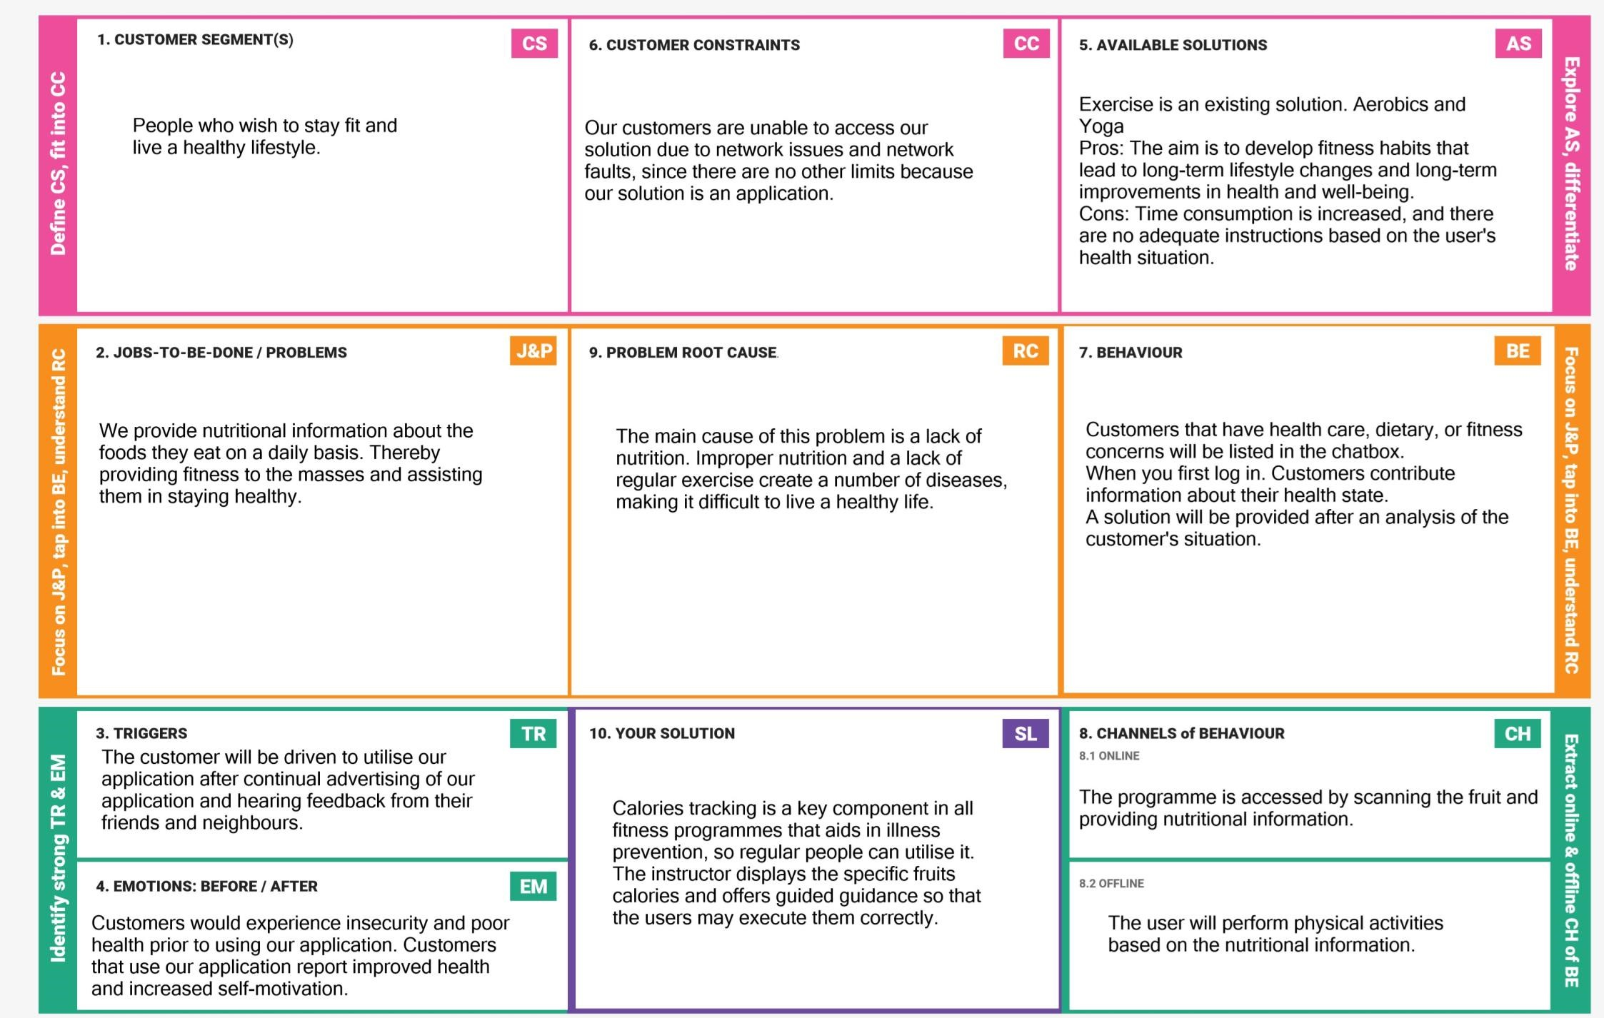

.

**Example:**

|  |  |  |  |  |  |
| --- | --- | --- | --- | --- | --- |
| **Problem**  **Statement (PS)** | **I am**  **(USER)** | **I’m trying to** | **But** | **Because** | **Which makes me feel** |
| PS-1 | Give image as input | Check the healthy facts in fruit | In take good food that gives immunity to our body | To get more fit | Intake of good fruits |